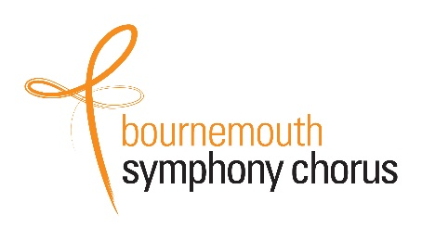**Yes! – I would like to become a**

**Bournemouth Symphony Chorus Benefactor.**

**Please provide us with your details:**

|  |  |
| --- | --- |
| **Title(s):** | Click here to enter text. |
| **Name(s):** | Click here to enter text. |
| **Address Line 1:** | Click here to enter text. |
| **Address Line 2:** | Click here to enter text. |
| **Town:** | Click here to enter text. |
| **Post Code:** | Click here to enter text. |
| **Mobile:** | Click here to enter text. |
| **Telephone:** | Click here to enter text. |
| **Email:** | Click here to enter text. |

**I agree that this data may be kept and used according to your Data Protection Policy to be found at** [**https://www.bschorus.co.uk/data-protection-policy**](https://www.bschorus.co.uk/data-protection-policy) **Please tick:**

**Please choose your membership by ticking one box:**

**Silver Membership £100 per annum**

* Priority Booking
* Ticket discounts for BSC promoted concerts
* Complimentary programmes
* Accreditation on the BSC website
* Regular Newsletters
* An invitation to the annual Benefactors Reception

**Gold Membership £250 per annum**

**Gold Membership (couples) £300 per annum**

* As Silver Membership Plus
* Ticket discounts at all concerts at which the BSC performs
* Accreditation in BSC Programmes
* Two (or four) best complimentary seats for one concert each year (subject to availability)
* Two (or four) places at the Annual Benefactors Reception

If you wish your name(s) to be printed, how would you like it/them to appear?

**Click here to enter text.**

If you would prefer to remain anonymous, please tick here:

**Payment Details:** Please tick ONE box

|  |  |  |  |  |  |  |  |
| --- | --- | --- | --- | --- | --- | --- | --- |
| I have set up a standing order to: Bournemouth Symphony Chorus  Sort Code: 20-96-96  Account Number: 00174629  With the reference: ‘Benefactor’ |  | Silver | | Gold | | Gold (Couple) | |
| Annual | £100 |  | £250 |  | £300 |  |
| Quarterly | £25 |  | £62.50 |  | £75 |  |
| Monthly | £8.50 |  | £21 |  | £25 |  |

If you are unable to set up a standing order with your bank then please send a cheque payable to Bournemouth Symphony Chorus together with this form to the address below.

**Gift Aid:**

The Bournemouth Symphony Chorus is a registered charity Number: 1040282

Increase the value of your gift by a quarter at no cost to yourself, if you are a UK taxpayer

Please tick the Gift Aid Box:

I am a UK taxpayer and would like the Bournemouth Symphony Chorus to treat all donations I make now and in the future as Gift Aid donations.

|  |  |  |  |
| --- | --- | --- | --- |
| Signature:  A typed signature is acceptable, or you can cut and paste a picture of your signature. | Click here to enter text. | Date: | Click here to enter a date. |

|  |  |
| --- | --- |
| Thank you very much for your support.  Please return this form by post or email to:  Email: [ingarfield@btopenworld.com](mailto:ingarfield@btopenworld.com)  Tel: 01929 480322  Mobile: 07810414720 | Joan Ingarfield  Bournemouth Symphony Chorus Treasurer  Barrow Lee,  Calcraft Road,  Corfe Castle.  BH20 5EL |