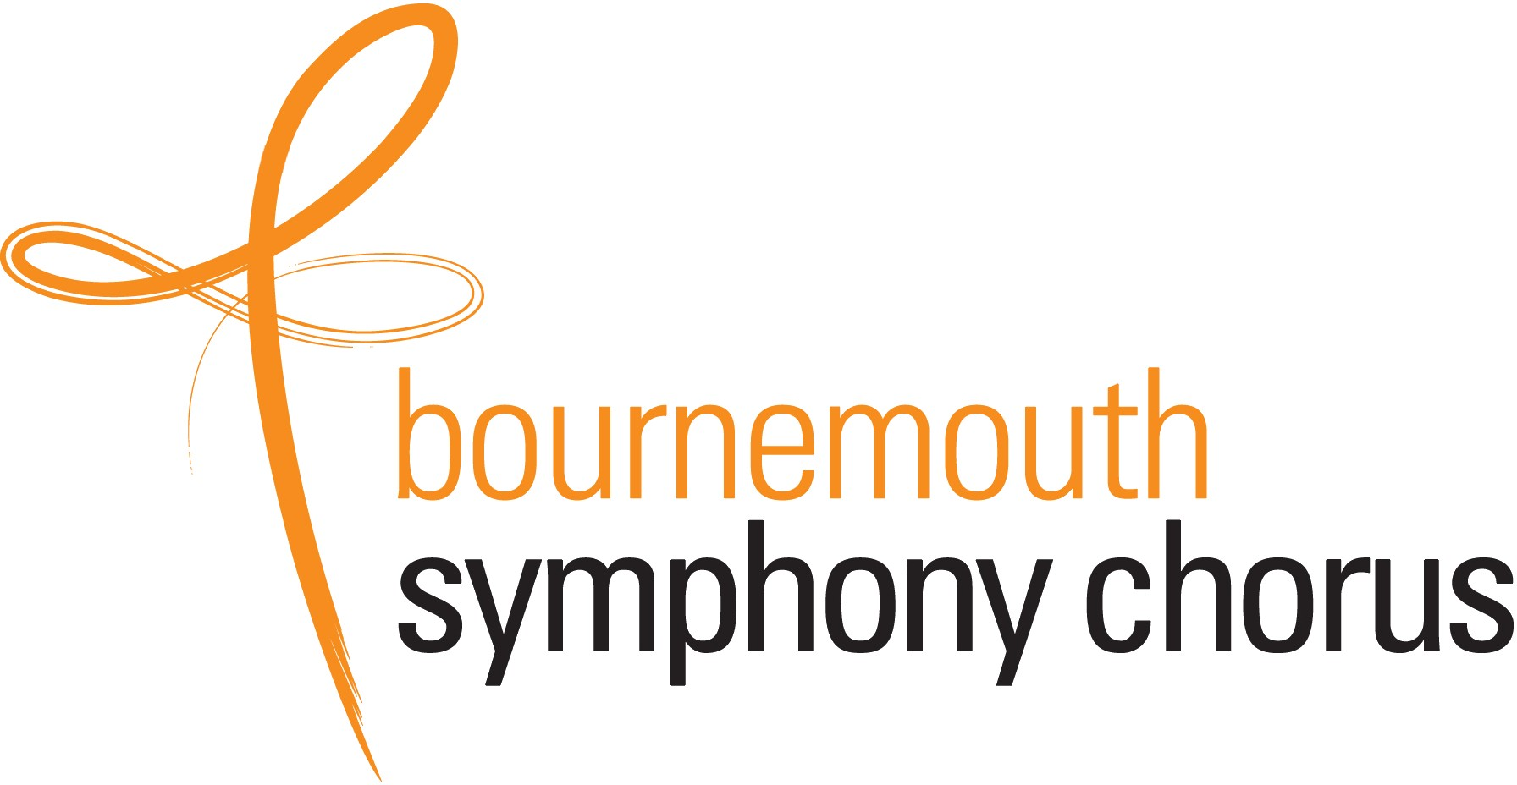 

# Sunday 26th January 2025 Lighthouse Poole BH15 1UG

EVERYBODY IS WELCOME!

Join Bournemouth Symphony Chorus and singers from across the region in a singing workshop followed by an informal run through of songs from some of the greatest Broadway shows including *Guys and Dolls, Jesus Christ Superstar* and Rodgers and Hammerstein. The day will be led by GAVIN CARR, inspirational Director of the BOURNEMOUTH SYMPHONY CHORUS and PHILHARMONIA CHORUS.

You don’t need to be in a choir – just keen to sing.

Book online at www.bschorus.co.uk or send the application form to THE BIG SING, Barrow Lee, Calcraft Road, Corfe Castle, BH20 5EL or to [BigSing@bschorus.co.uk](mailto:BigSing@bschorus.co.uk?subject=Big%20Sing%202025). The cost is £19 (under 18s £8) for the day including hire of your music which is issued to you when you arrive. PAY ON-LINE by BACS to Bournemouth Symphony Chorus, sort code: 20 96 96, account number 00174629 with reference: *your name* and BS2025 or send a cheque payable to BSC to the address above. Sorry no refunds.

Timetable for participants: **9.30am** Registration; **10am – 1pm** Morning session; **1pm – 2pm** Lunch interval (Lighthouse café open or bring a picnic); **2pm – 3.40pm** Afternoon session;

**4pm – 5pm** Run through (open to the public – tickets £7 available **only** from Lighthouse Box Office [www.lighthousepoole.co.uk](http://www.lighthousepoole.co.uk/) 01202 280000).

Call 01202 423429 or see online [www.bschorus.co.uk](http://www.bschorus.co.uk/) for further information

# SINGERS' APPLICATION FORM

**Your name(s)**

**in CAPITAL LETTERS**

**Put a ring round *your* voice part: Soprano Alto Tenor Bass**

|  |  |  |  |
| --- | --- | --- | --- |
|  |  |  |  |

**Number of singers on each voice:**

**Contact telephone number:**

|  |  |  |  |
| --- | --- | --- | --- |
|  | | **Any Under**  **18s:** |  |
|  | | | |
|  | ***OR* I enclose a cheque for:** | | **£** |

**Email address (please print):**

**I have paid by BACS (tick)**

If you don't have an email address, please supply your postal address and enclose a stamped, self-addressed envelope.

**You must either email this form to** [**BigSing@bschorus.co.uk**](mailto:BigSing@bschorus.co.uk) **or post it to: THE BIG SING 2025, Barrow Lee, Calcraft Road, Corfe Castle, BH20 5EL**

Your application will be acknowledged by email.

May we add you to our Mailing List? (We will *NOT* share it with anyone else). **Please tick:**