Ordering Example:
I wish to order “God Save the Queen” for the “Symphony With the Stars” Performance.
Note: on smaller screens you may have to scroll down and scroll right to see items.
Also the Menu may be accessed via the menu symbol of three horizontal parallel lines:
1) Log in to my bsc account:
https://www.bschorus.co.uk/
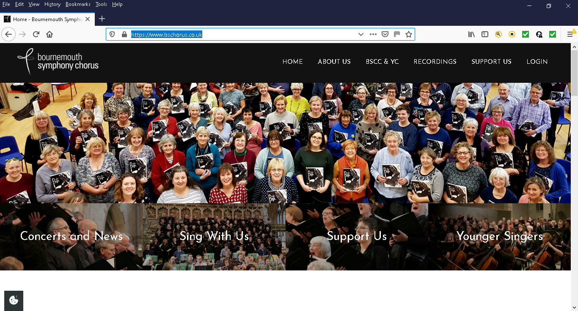
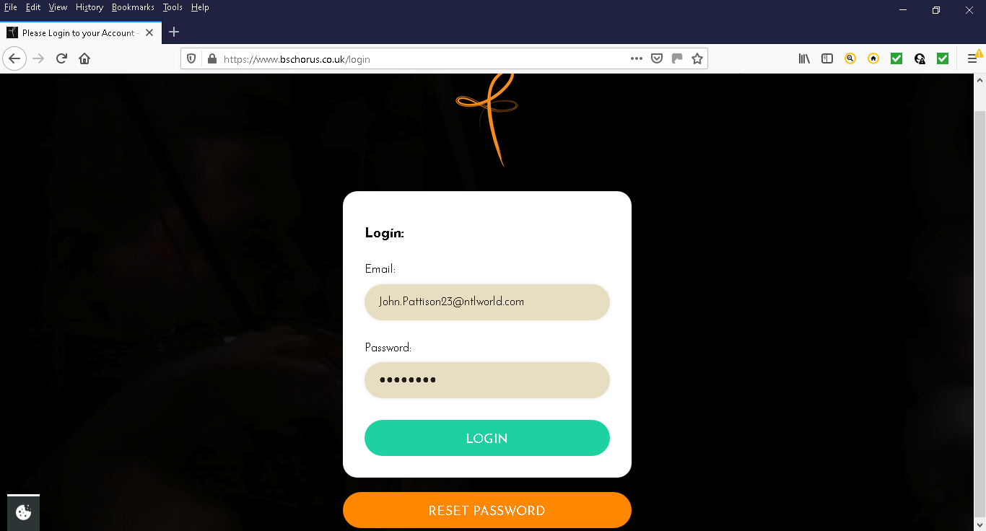
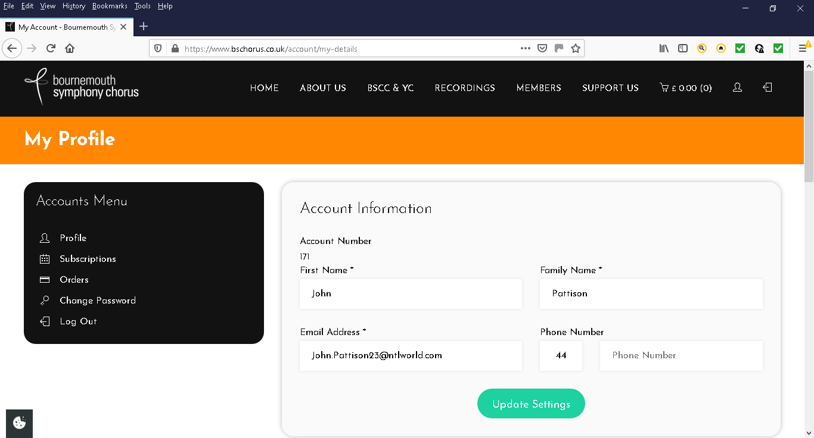
2) Select the “Members” menu item
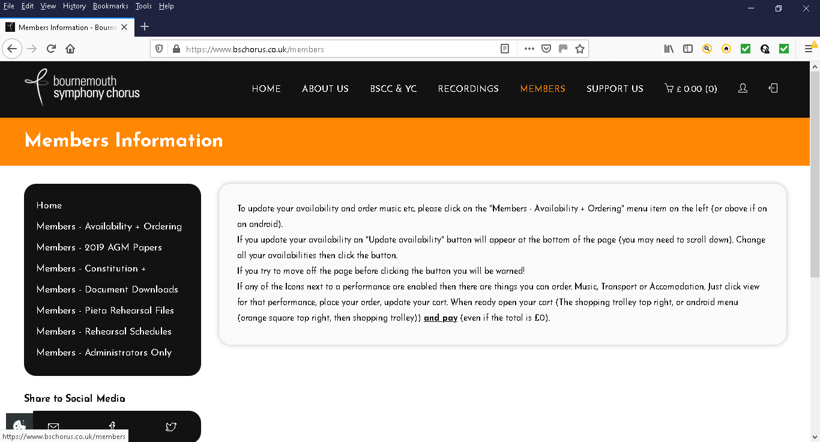

3) Select “Members –Availability + Ordering”
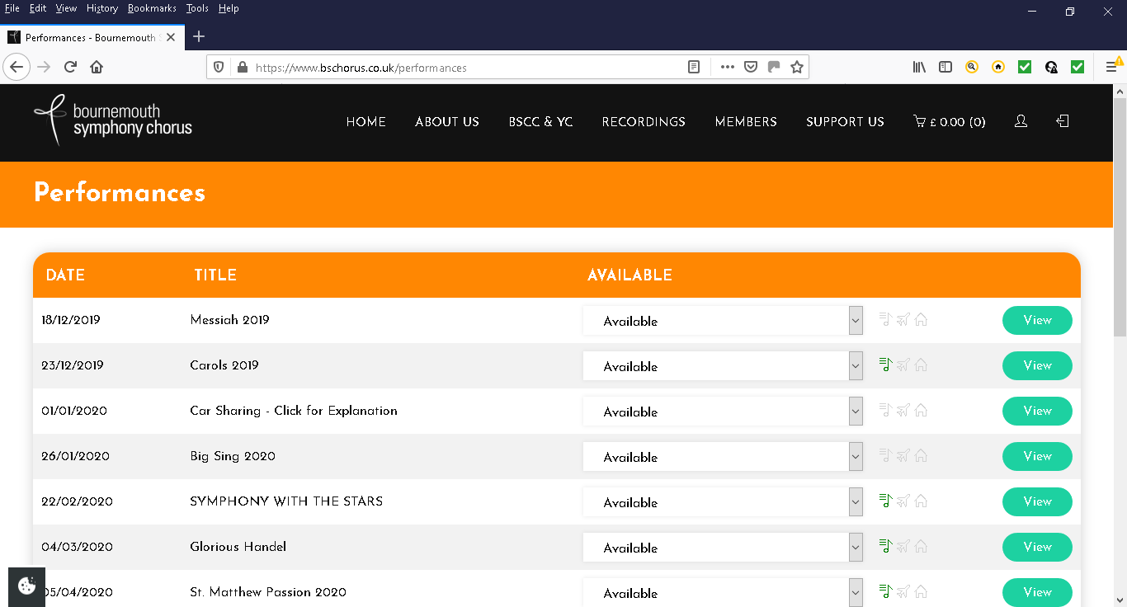
4) Select the Performance “Symphony with the stars” – click on the title OR the symbol OR <view>
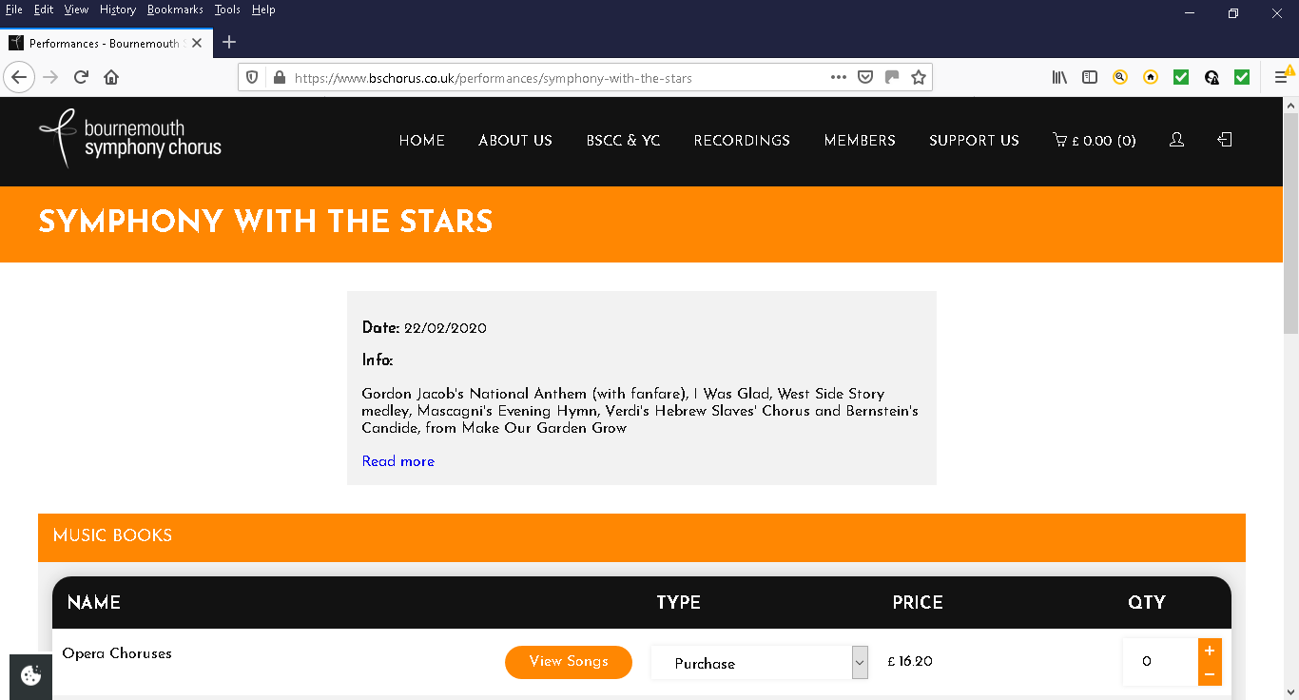
5) Scroll down
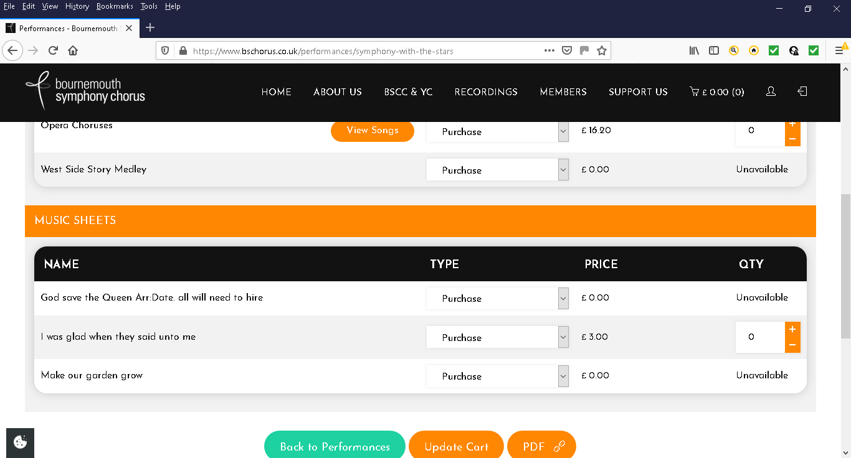
6) Click on the down arrow under “TYPE” for the music where it currently says Purchase.
It will give you two choices Purchase or Hire please Select HIRE.
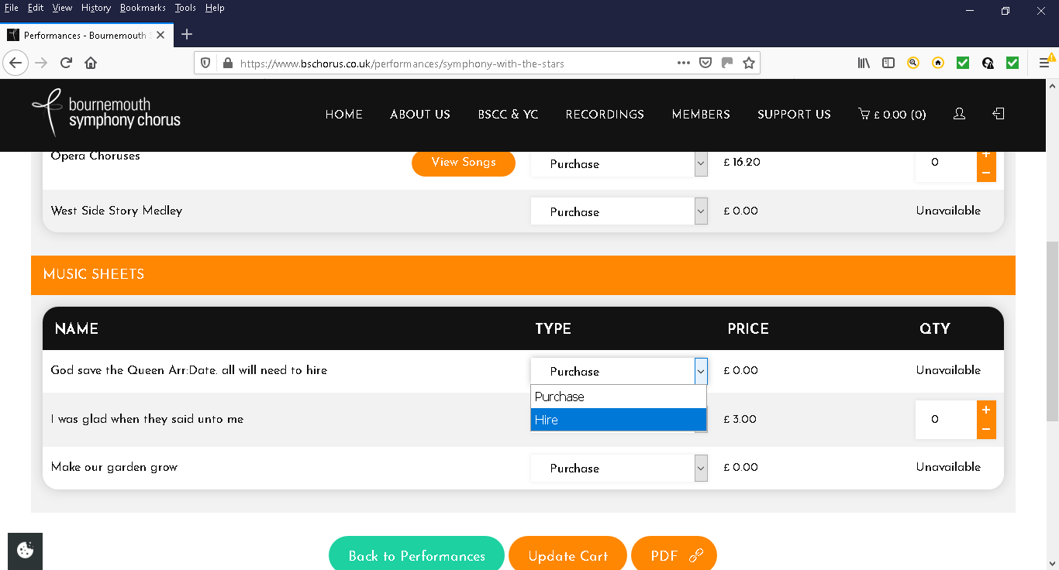
7) Select “HIRE” on the list.
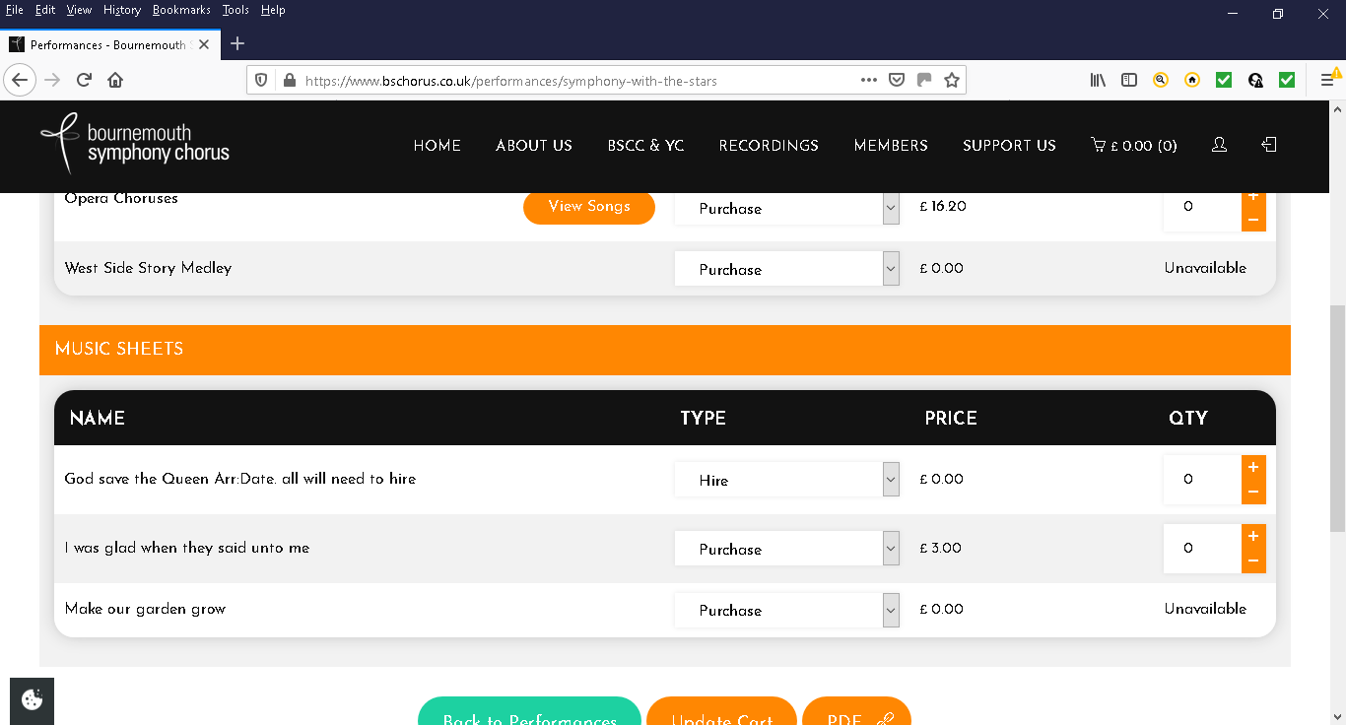
8) Select the quantity required
9) Repeat for as many items as you require
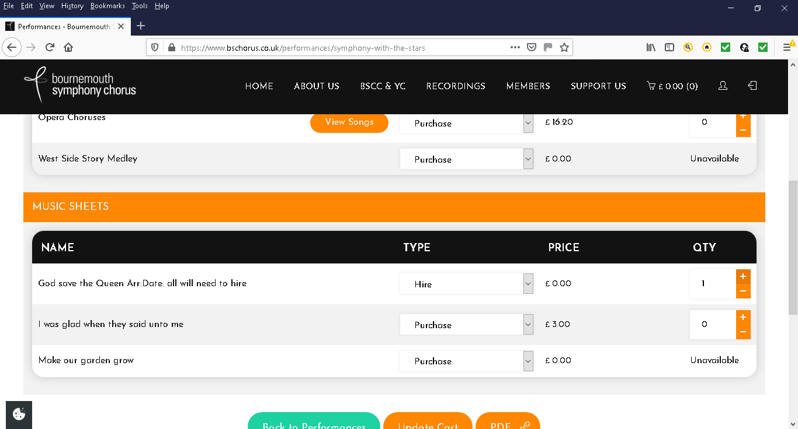
9) Update your shopping cart
(you will see the cart displaying the items and their value next to the shopping trolley symbol on the menu)
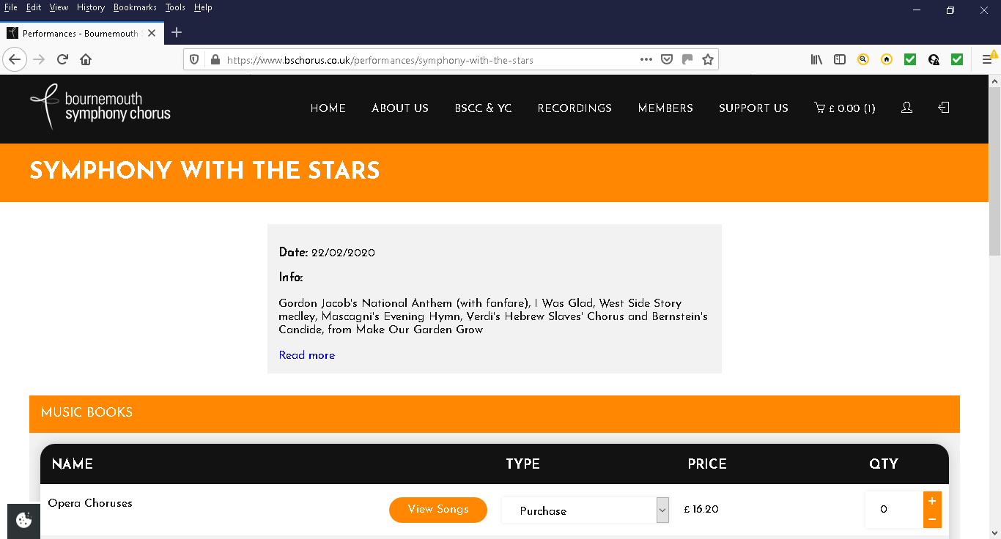
10) When you have added all the items you want then Click on your Cart to go to the payment page:
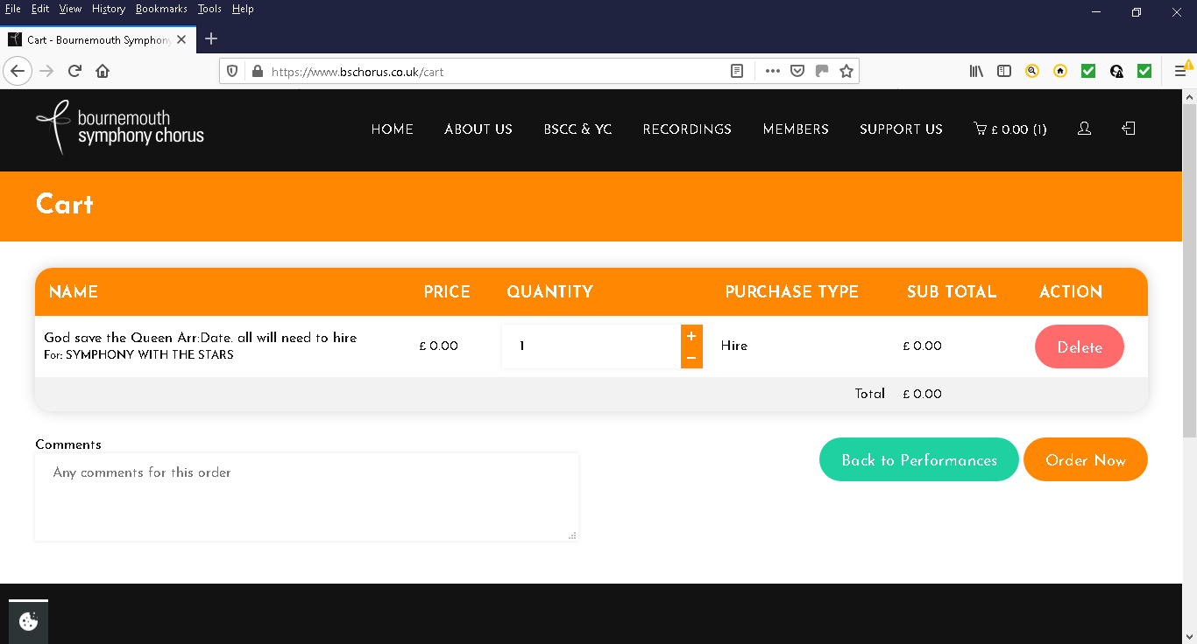
11) Check the items are as you require and amend if necessary
12) For £0.00 Total Click <Order Now> OR for non-zero Click <Pay Now> and follow the Paypal instructions.

